APi uses in mahadialysis website

1. Login Api

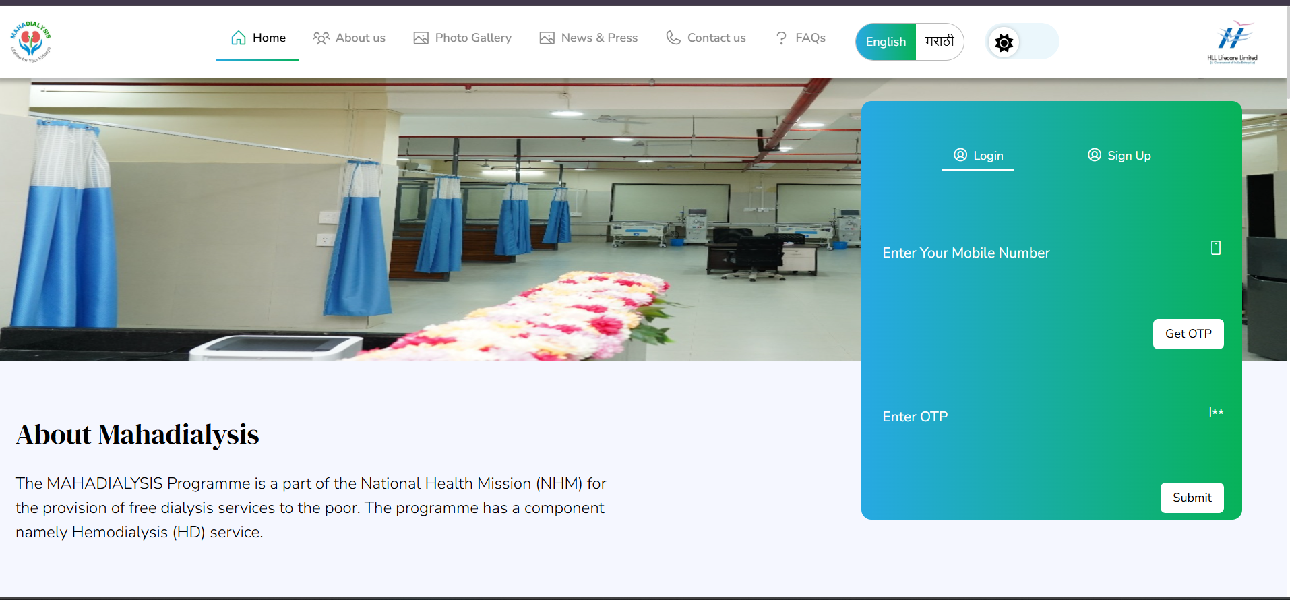

Login Api

<http://210.89.42.115:9999/HAEMODIALYSIS-Replica/restApi/checkPatIdorMobileOrAbha?mobileNo=9372818672&userflag=&patientId>

key parameter pass mobile no for hit the api

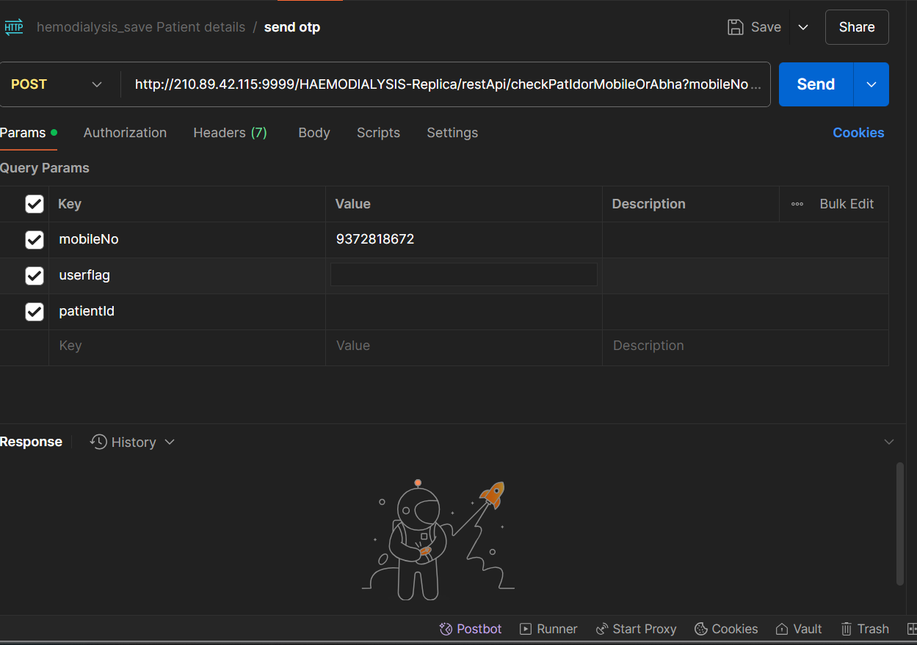

1. Sign up api

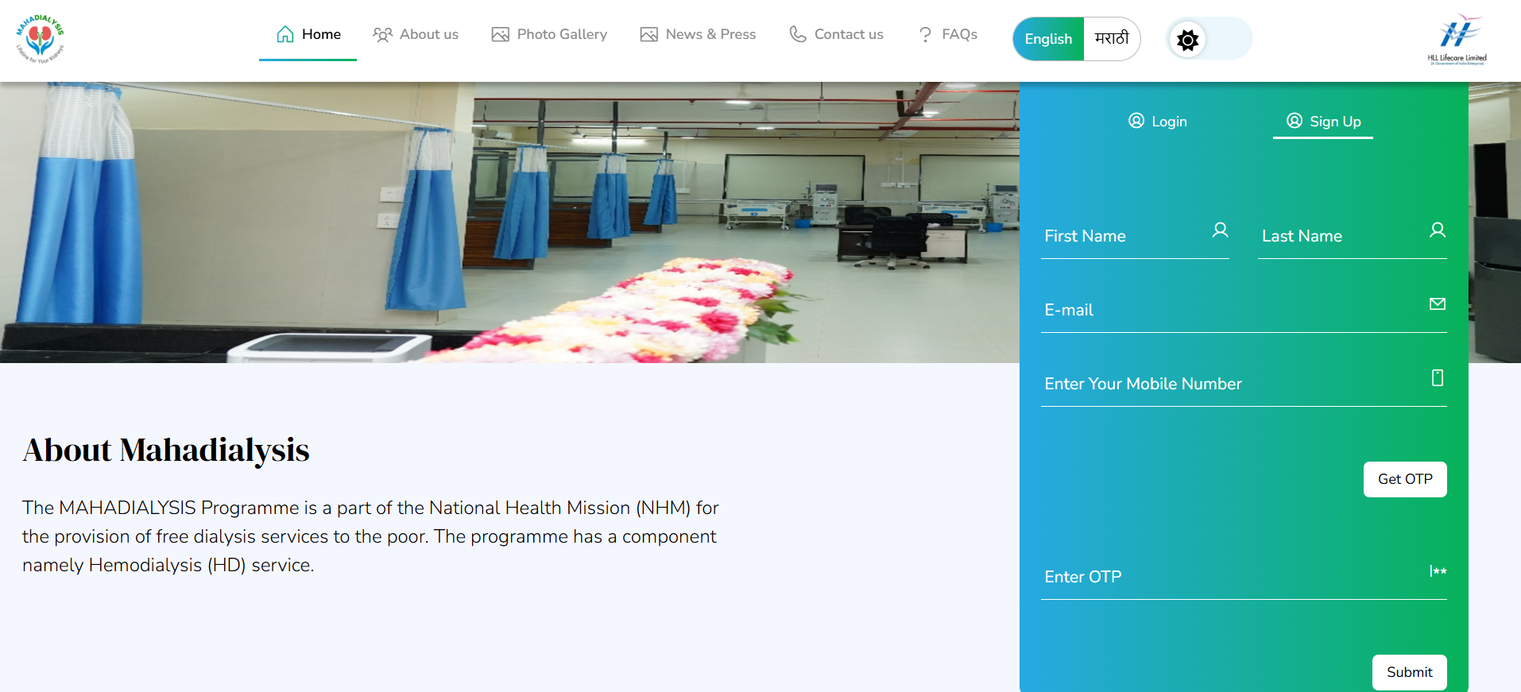

<http://210.89.42.115:9999/HAEMODIALYSIS-Replica/restApi/checkPatIdorMobileOrAbha?mobileNo=9372818672&userflag=S&patientId> key parameter pass mobile no and pass the S user flag for hit the api

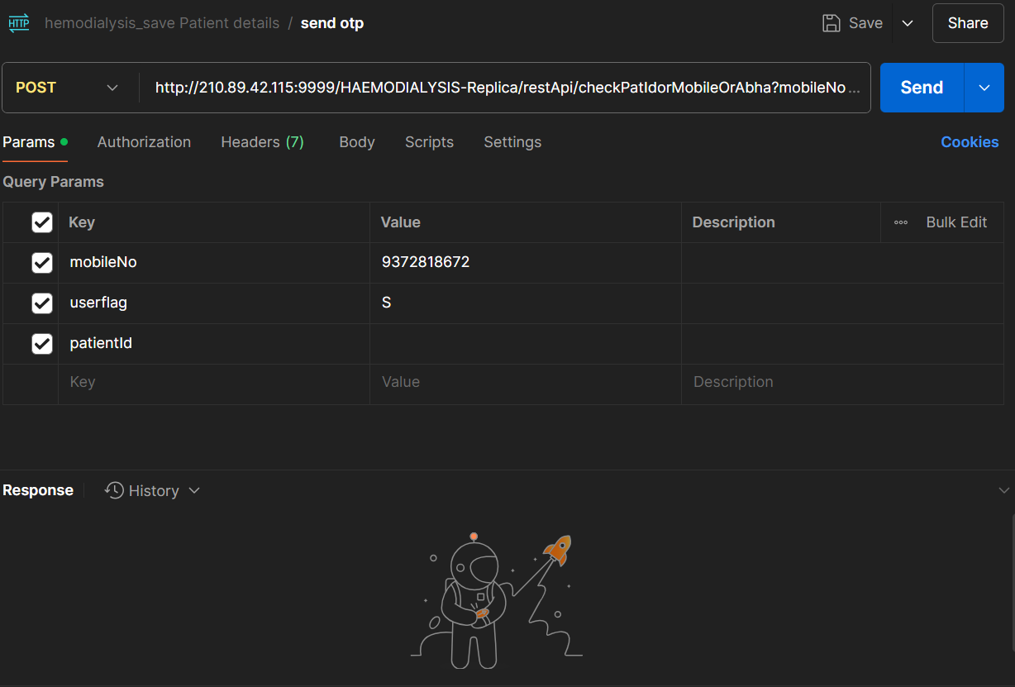

1. Count api

Count api required from to todste to know the dashboard count

<http://210.89.42.115:8080/Hemodialysis-Apis/dashborad/getNewDashboardCount?fromDate=2022/01/01&toDate=2024/09/27&unitId=0>

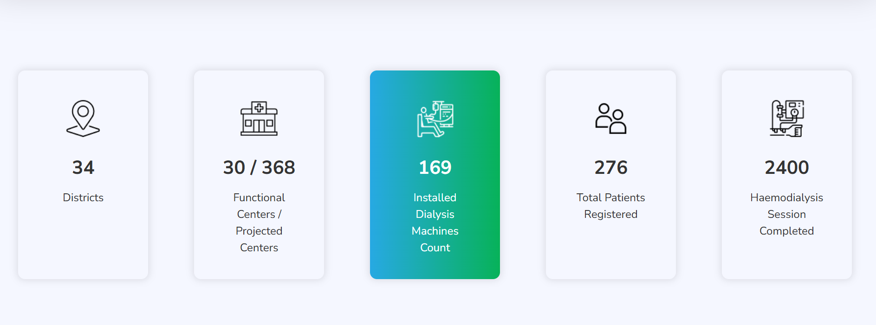

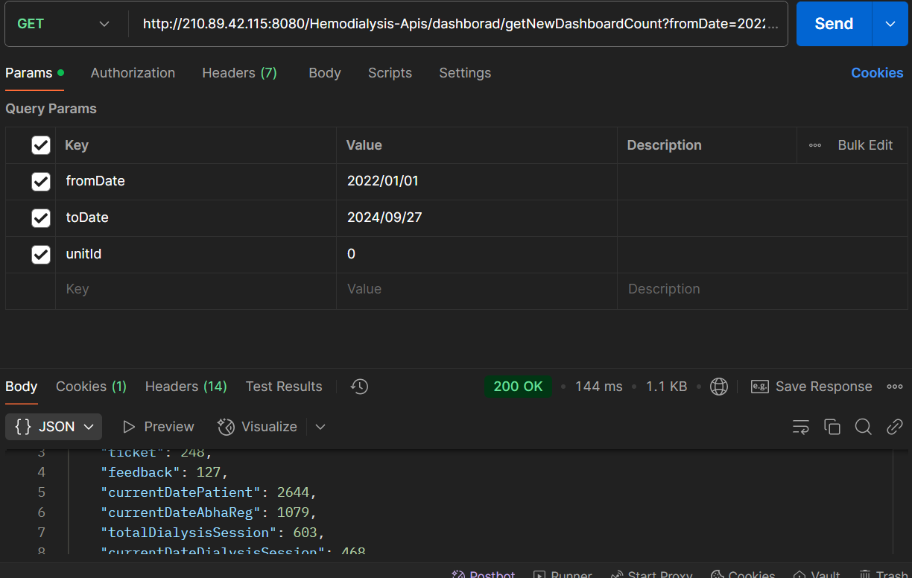

1. User dashboard count api

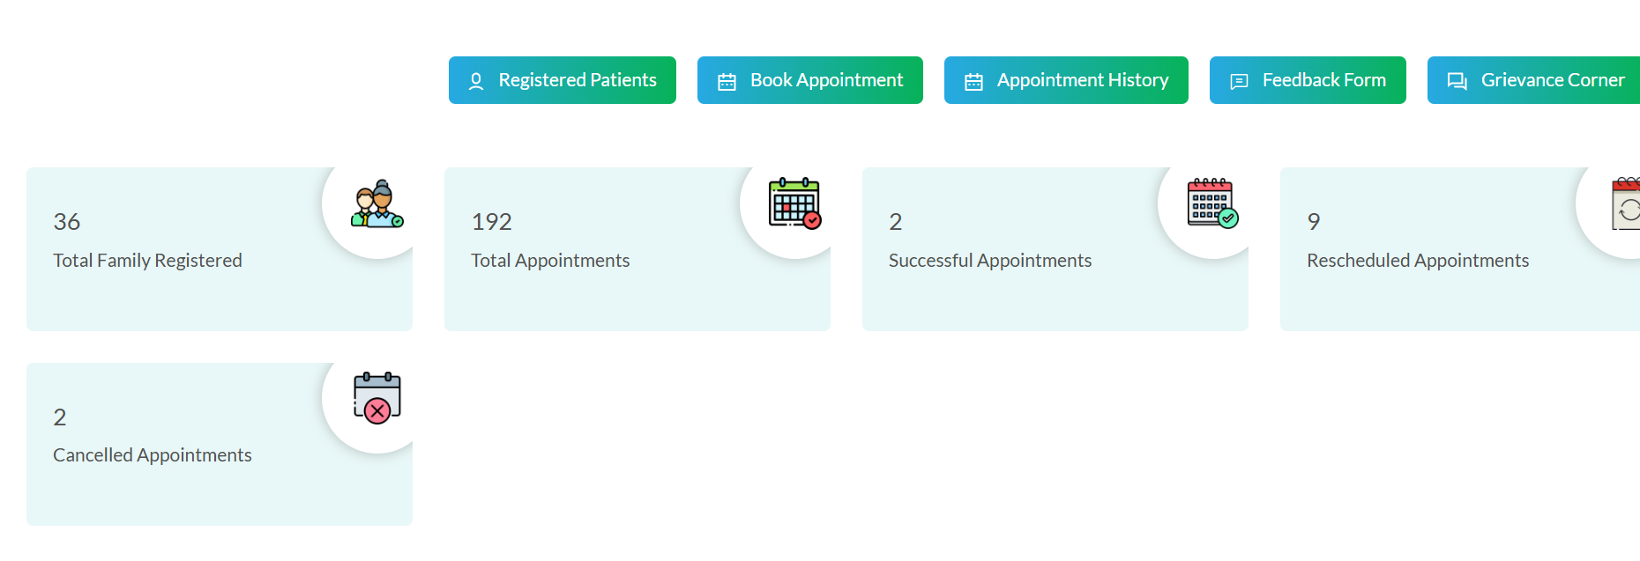

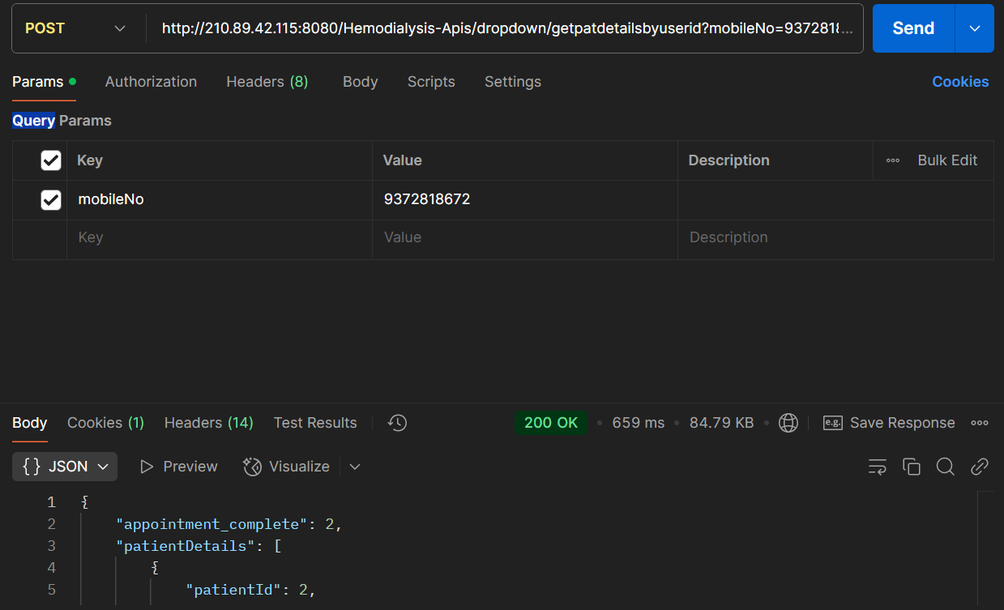in this api dashboard count api work using key as phone number

<http://210.89.42.115:8080/Hemodialysis-Apis/dropdown/getpatdetailsbyuserid?mobileNo=9372818672>

1. registered patient show data api

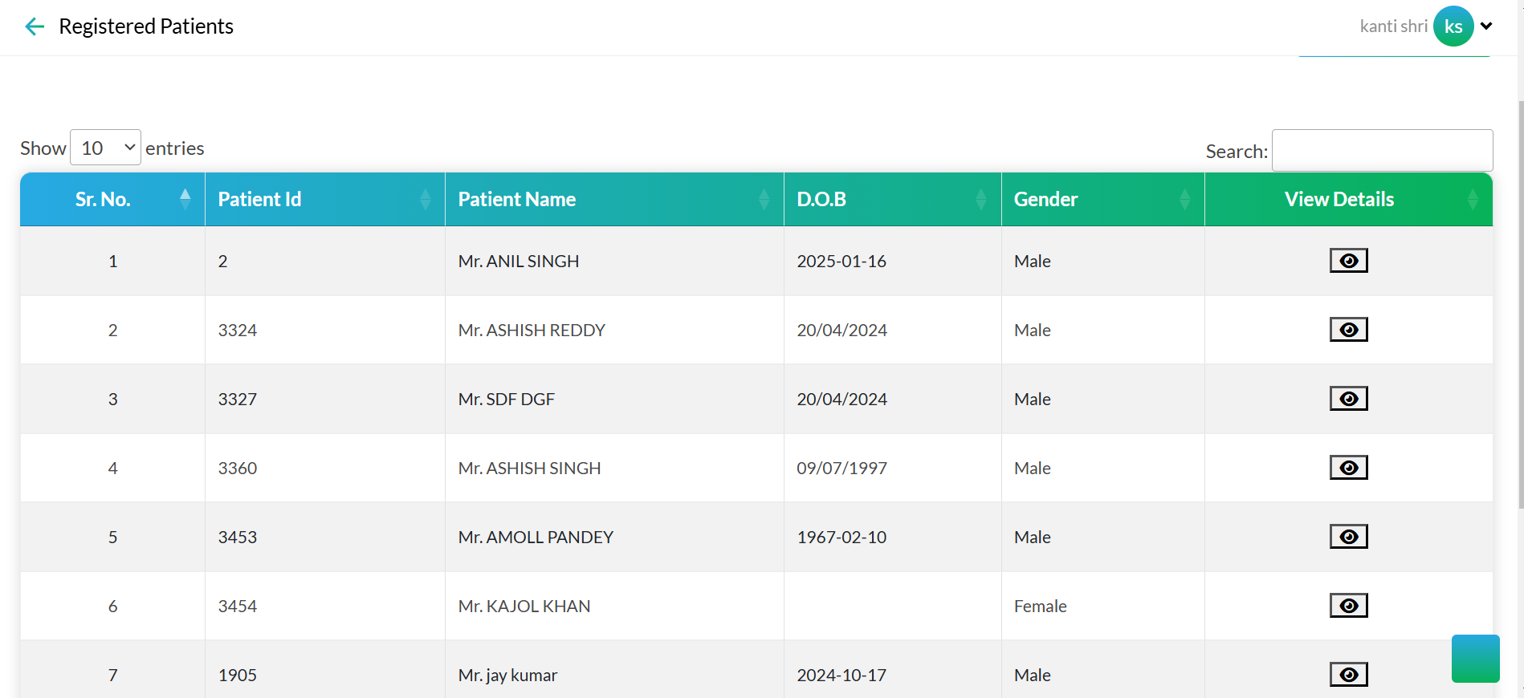

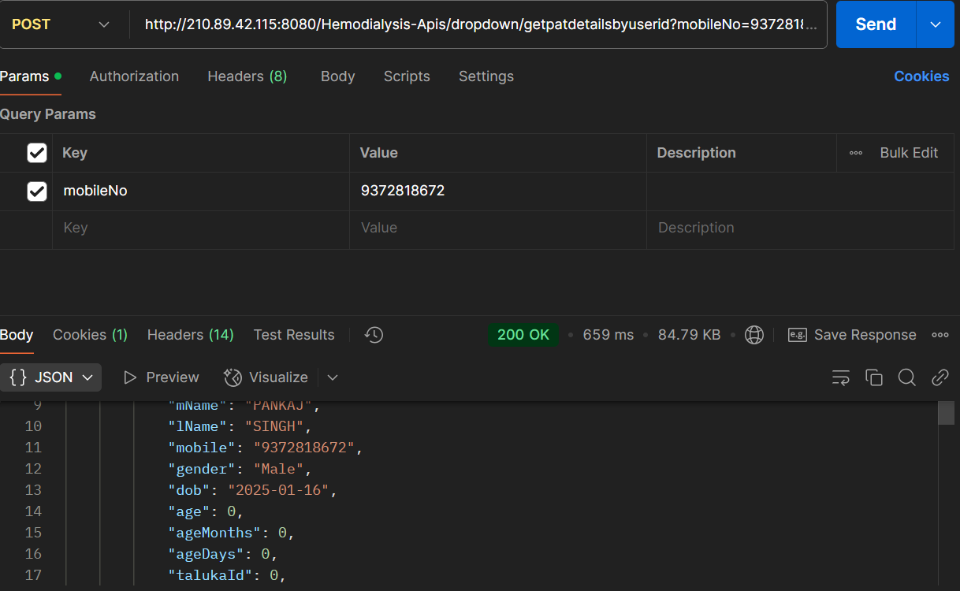in this api key parameter is user mobile number this api works all function to show the data

1. api for patient pre registration

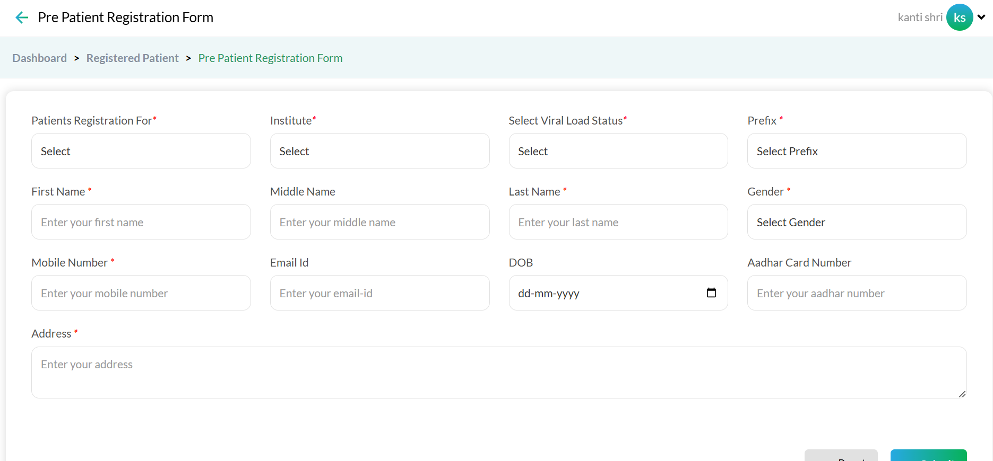

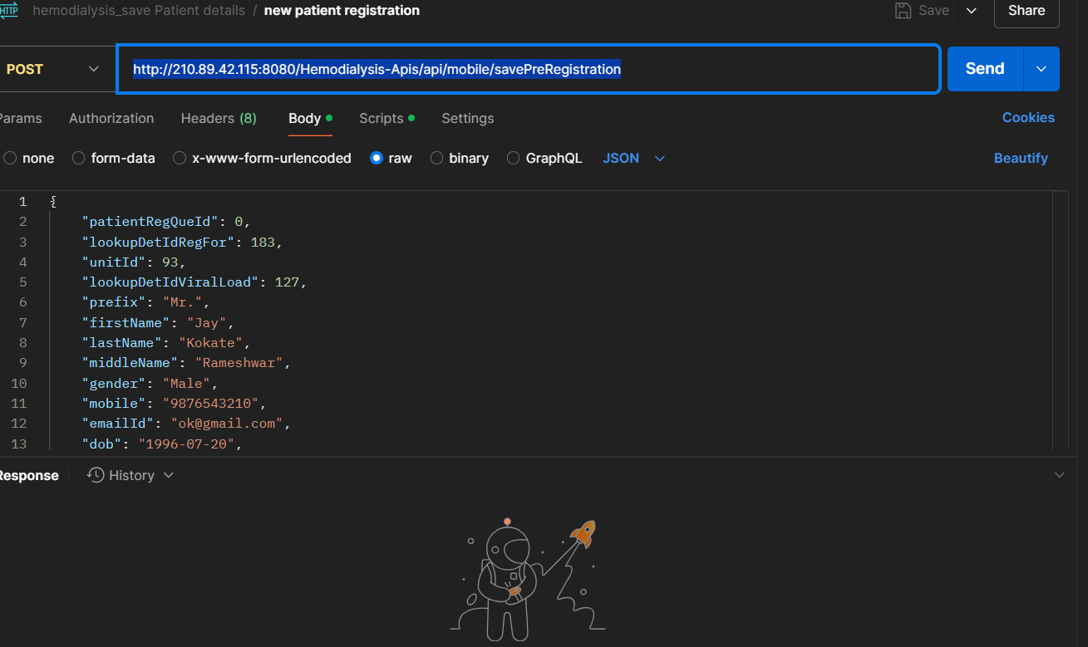 <http://210.89.42.115:8080/Hemodialysis-Apis/api/mobile/savePreRegistration>

In this {

    "patientRegQueId": 0,

    "lookupDetIdRegFor": 183,

    "unitId": 93,

    "lookupDetIdViralLoad": 127,

    "prefix": "Mr.",

    "firstName": "Jay",

    "lastName": "Kokate",

    "middleName": "Rameshwar",

    "gender": "Male",

    "mobile": "9876543210",

    "emailId": "ok@gmail.com",

    "dob": "1996-07-20",

    "adhaarCardNo": "987654321234",

    "address": "Kalyan",

    "createdBy": 256,

    "createdDate": "2024-12-17T00:00:00Z",

    "deviceFrom":"mobile"

}

This json required for the hit api

1. Existing patient api

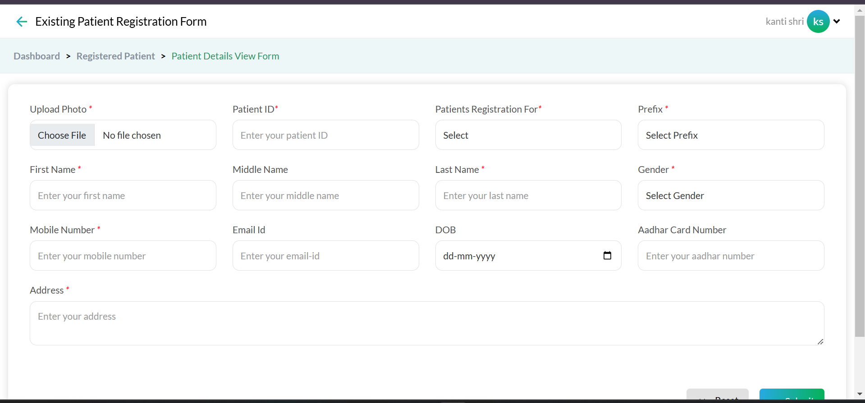

This api save update and mapping to the user

<http://210.89.42.115:8080/HAEMODIALYSIS/patregistration/savePatientRegDetails>

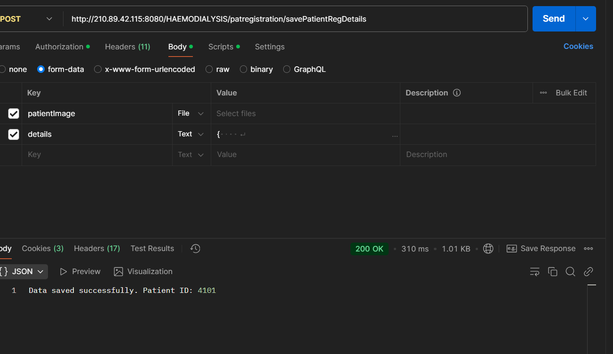

In this another api works fetching abi usin patient id all data will appear when patient I d insert in the given form

http://210.89.42.115:8080/HAEMODIALYSIS/new-complaint/getPatDetForCompForm

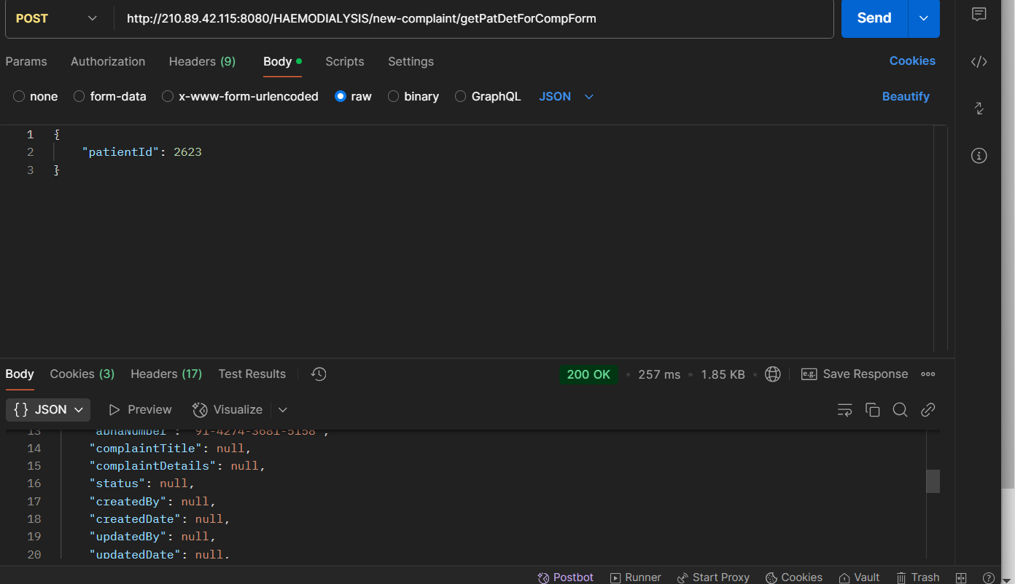

1. book appointment api

<http://210.89.42.115:8080/Hemodialysis-Apis/hemodialysis-api/saveSchedular>

this body required

    [

        {

            "userId": 600,

            "patientId": 1905,

            "slotId": 244,

            "bedAllocationDate": "14-01-2025",

            "unitId": 105

        }

    ]

To save api this details required

In this patient fetch api also using for show and use patient id to save slot

<http://210.89.42.115:8080/Hemodialysis-Apis/dropdown/getpatdetailsbyuserid?mobileNo=9372818672>

in this auto institutes select as per patient selected

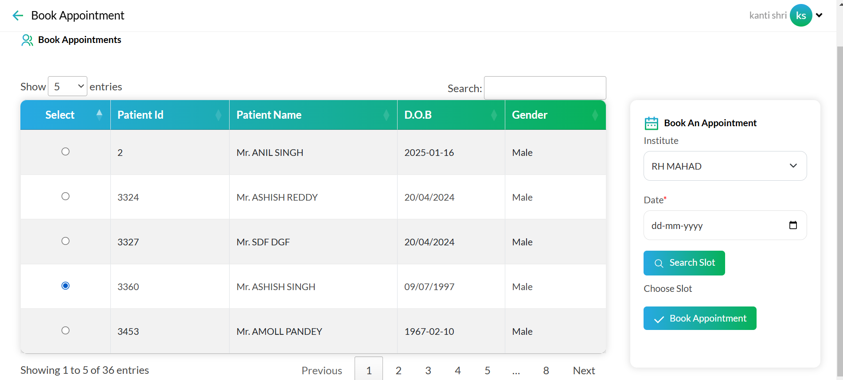

<http://210.89.42.115:8080/Hemodialysis-Apis/hemodialysis-api/unit-address>

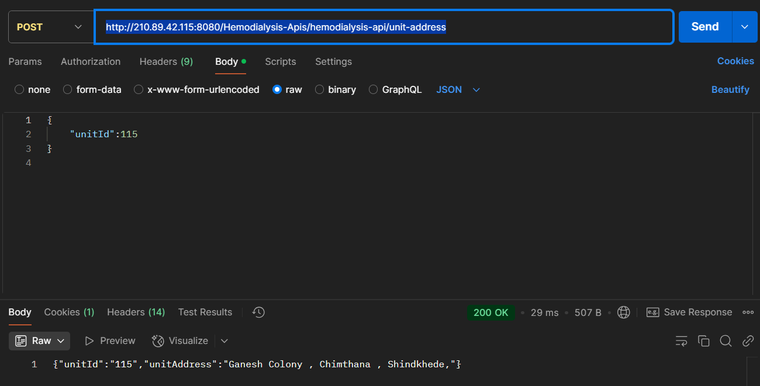

In this for slot save fetch api use 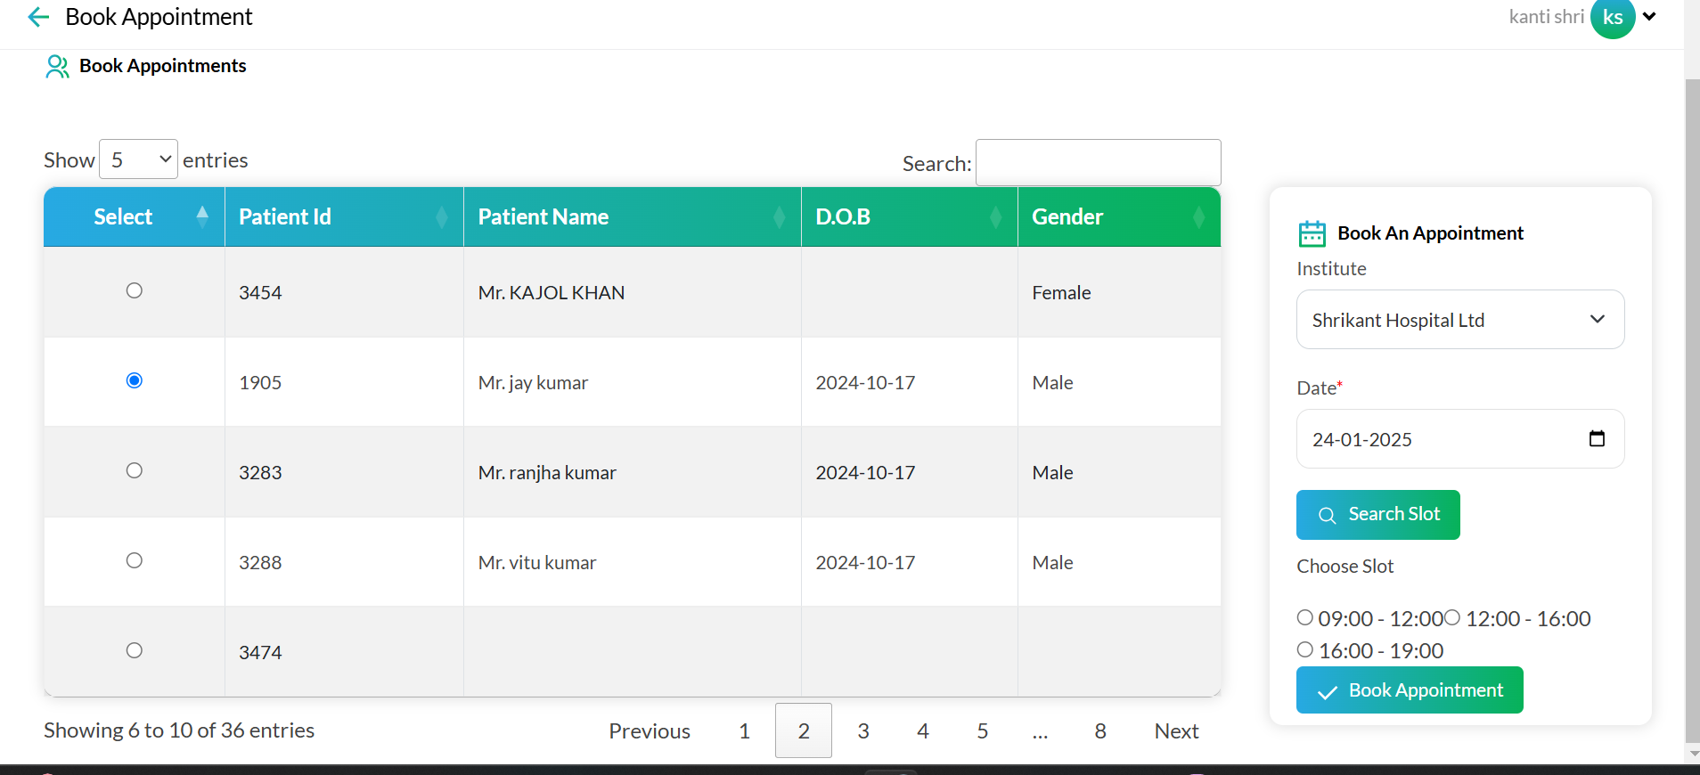

<http://210.89.42.115:8080/Hemodialysis-Apis/hemodialysis-api/getavailableslots>

using this api get available slot using this filed required   
{

    "patientId":"3980",

    "unitId":"157",

    "date":"29-JAN-2025"

}

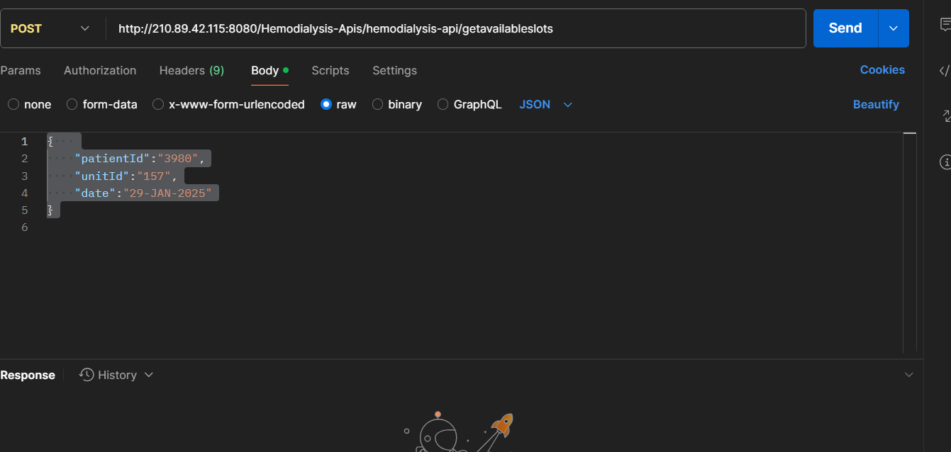

Appointment history api

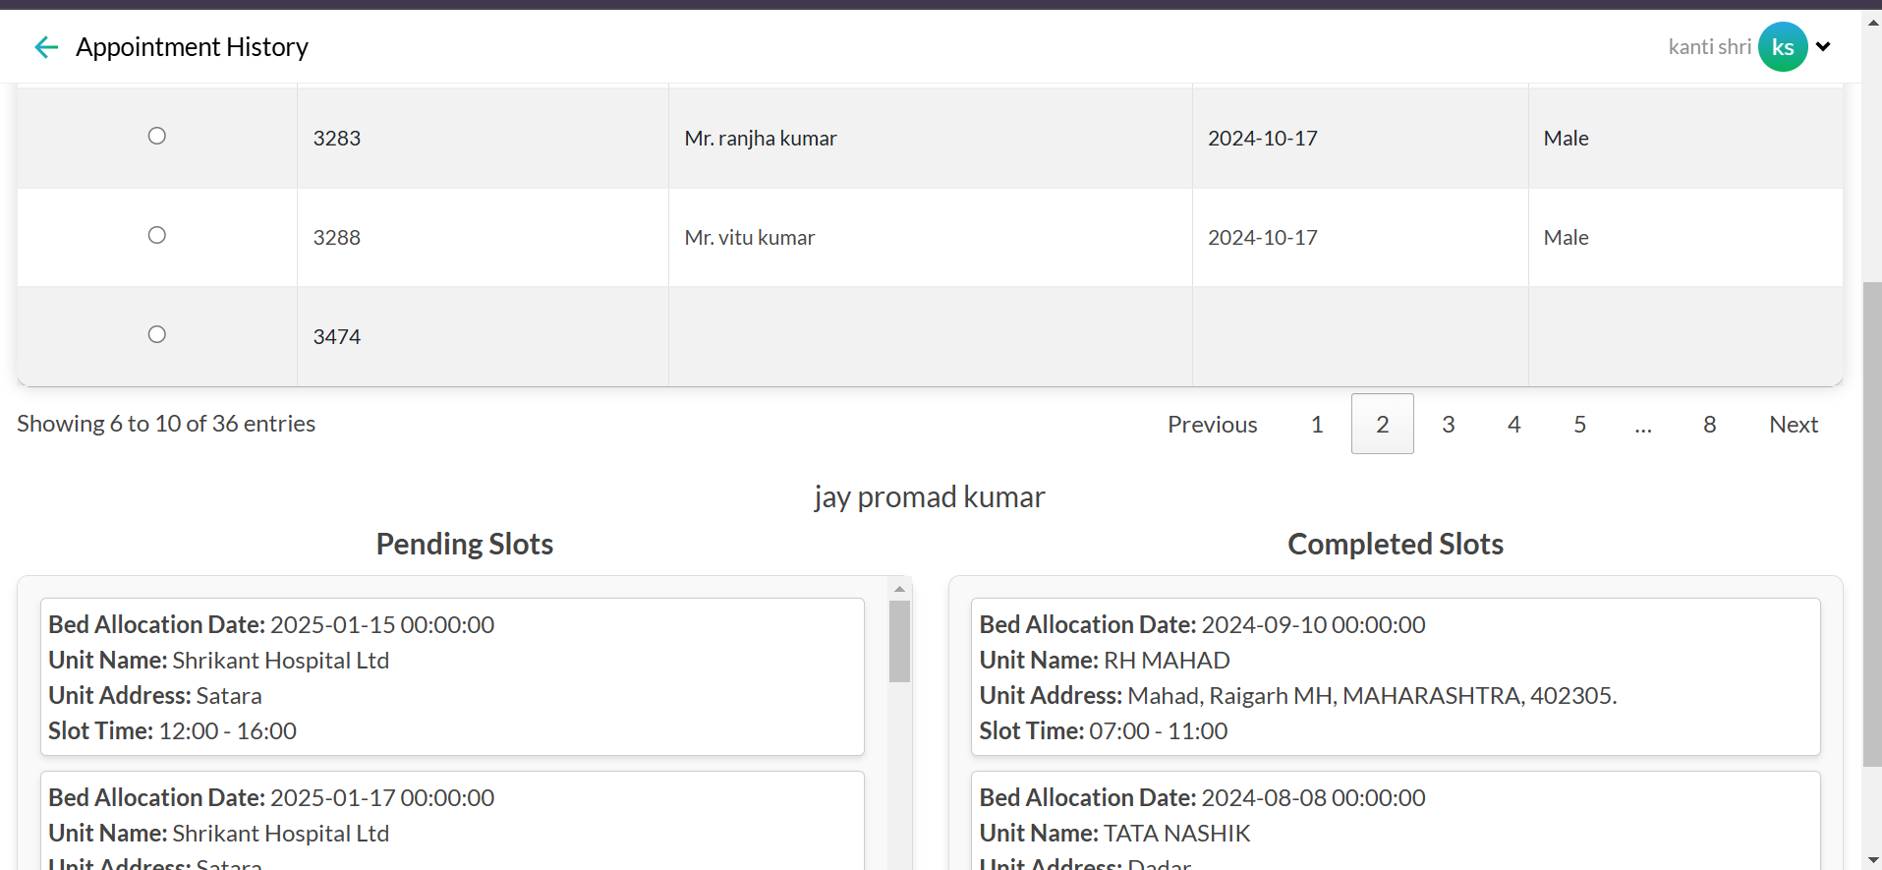

In this api show patient history of appointment

This api required patient id

{

    "patientId" : 1905

}

<http://210.89.42.115:8080/Hemodialysis-Apis/hemodialysis-api/patient-dialysis-record>

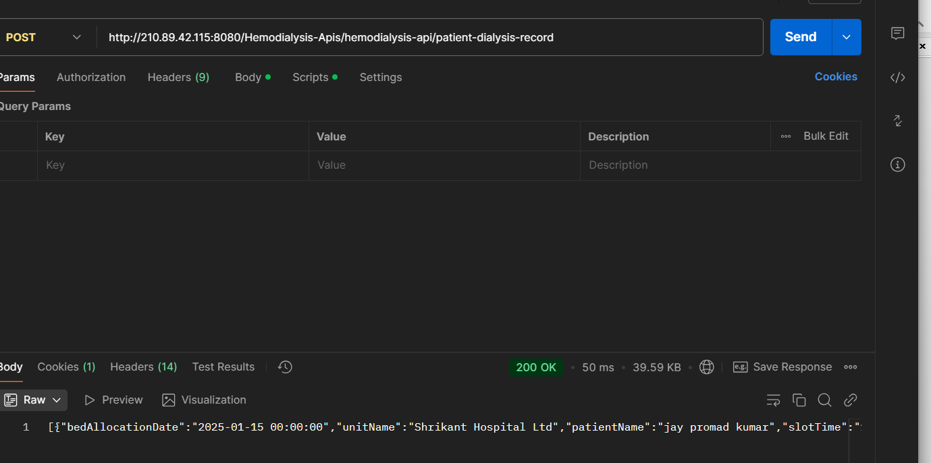

Save api for feedbackform

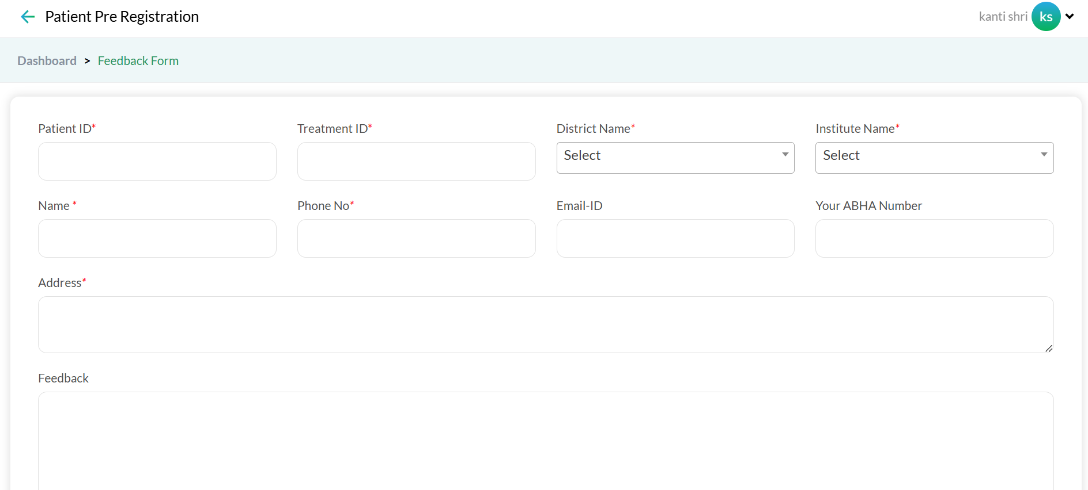

This api required this field

<http://210.89.42.115:8080/HAEMODIALYSIS/feedback/saveFeedbackforwebsite>

{

    "abhaNo": "98-0887-8787-8777",

    "lastName": "MANE",

    "address": "Plot No. 37 Chandra Nagar, Post Bhagwan Nagar Near NIT Garden Behind Naik Hospital, Nagpur 440027",

    "unitName": "WH WARDHA",

    "districtName": "WARDHA",

    "patientId": 2304,

    "mobile": "3434343434",

    "treatmentId": 2701,

    "firstName": "MEERA",

    "districtId": 24,

    "unitId": 116,

    "middleName": "MANOJ",

    "email": "21@gmail.com"

}

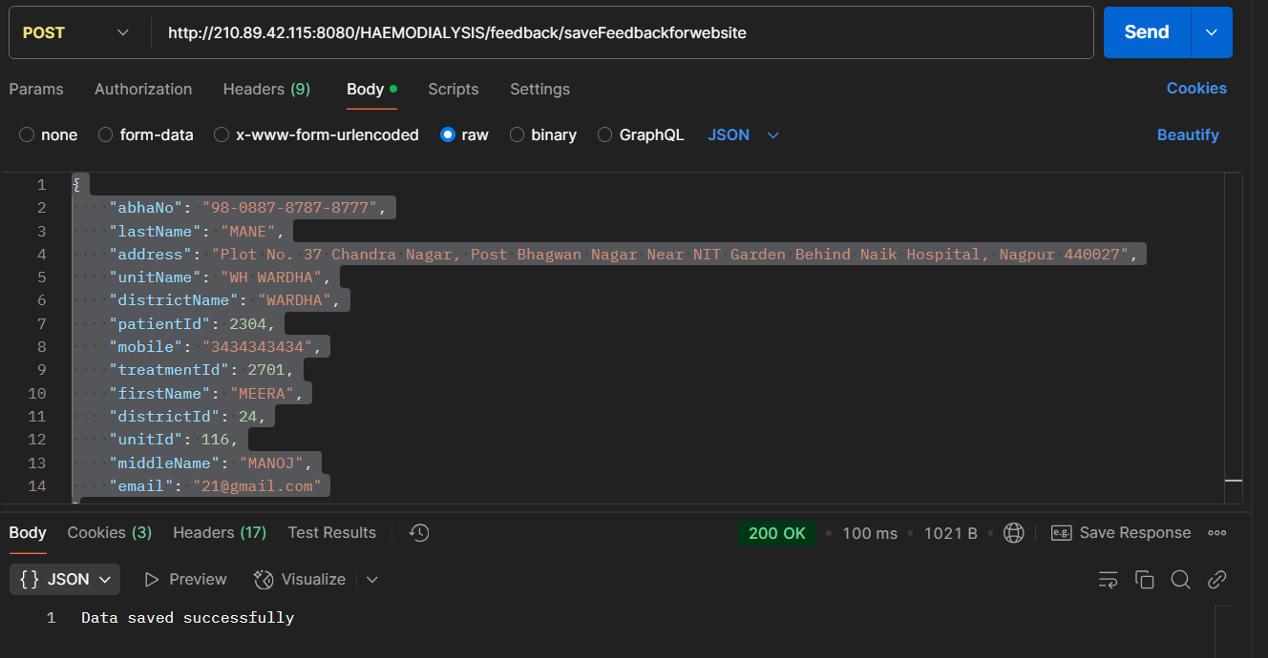

In this form also using qr submission method using api this api uses patient is and latest treatment id

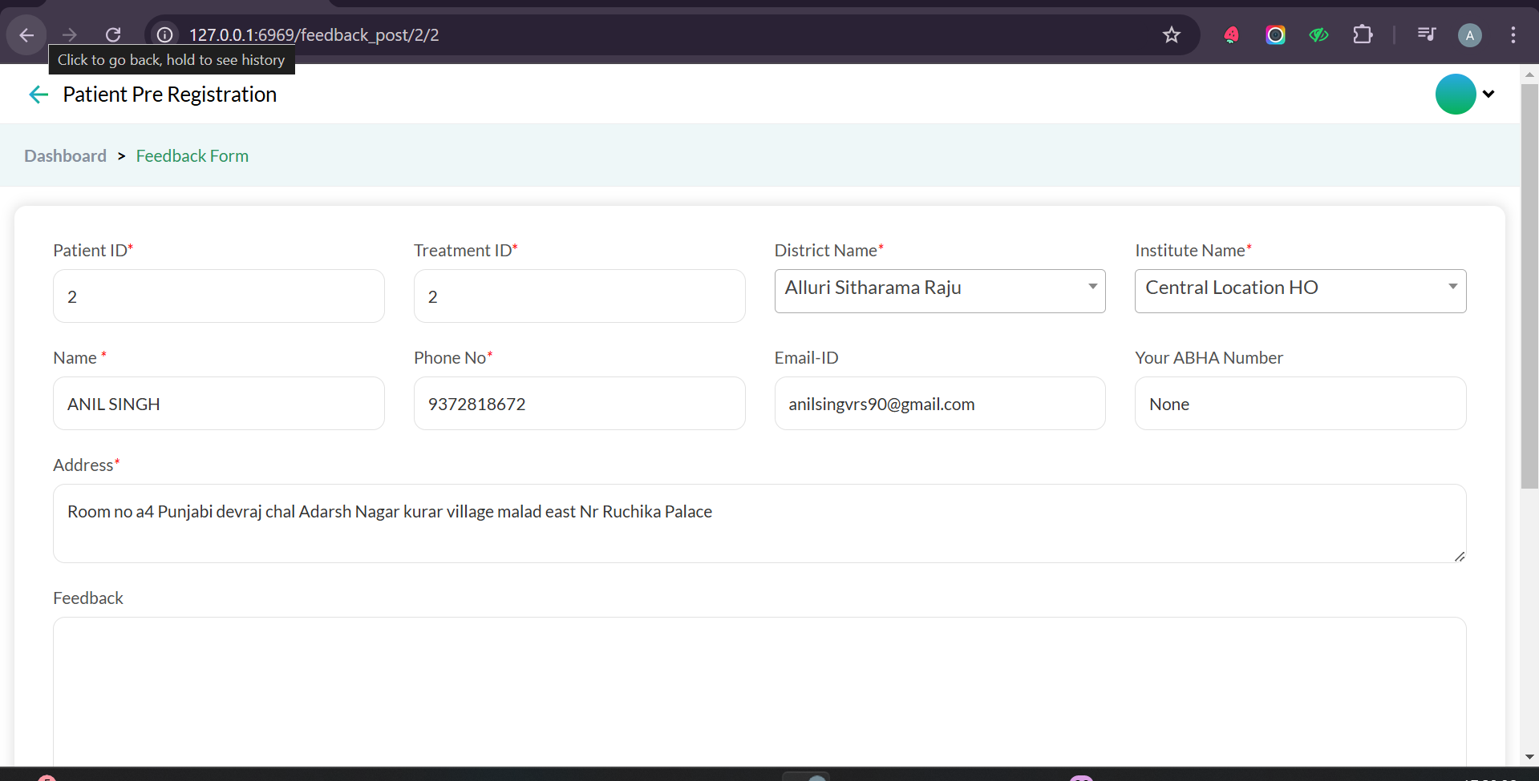http://127.0.0.1:6969/feedback_post/2/2

Here qr url hits like above link that on is patient id and treatment id

<http://210.89.42.115:8080/HAEMODIALYSIS/feedback/getPatientDetails?patientId=2&treatmentId=2>

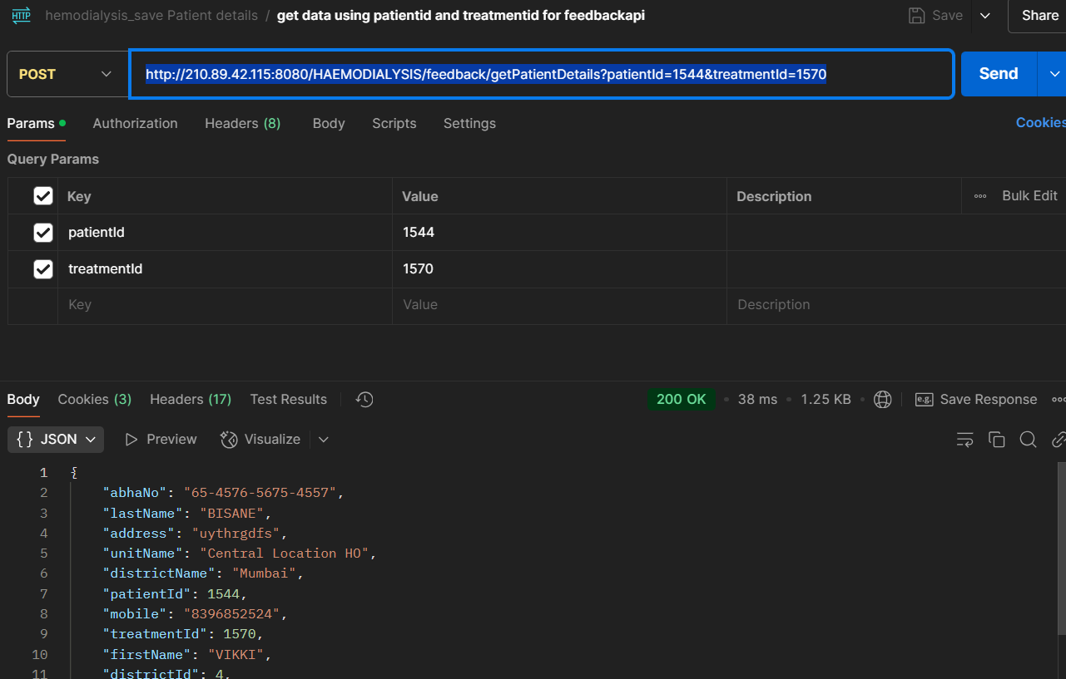

In this using patient id fetch data api also working

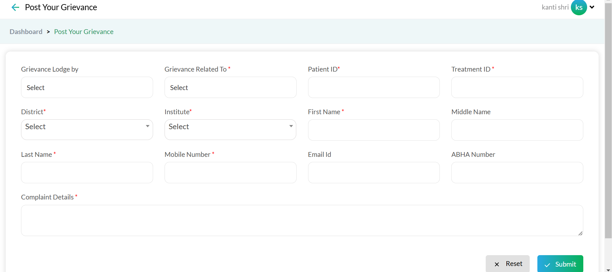

Save api for Grievance Form api

<http://210.89.42.115:8080/HAEMODIALYSIS/new-complaint/saveComplaintDetails>

{

    "serviceCode": "TMH",

    "patientId": "1",

    "treatmentId": "1",

    "distId": "27",

    "unitId": "166",

    "firstName": "RINKU",

    "middleName": "AMOL",

    "lastName": "KAMBLE",

    "patientPhoneNo": "9763110666",

    "patientEmailId": "",

    "abhaNumber": "",

    "complaintTitle": null,

    "complaintDetails": "QAWSDFVB",

    "complaintLodgeBy": "439"

}

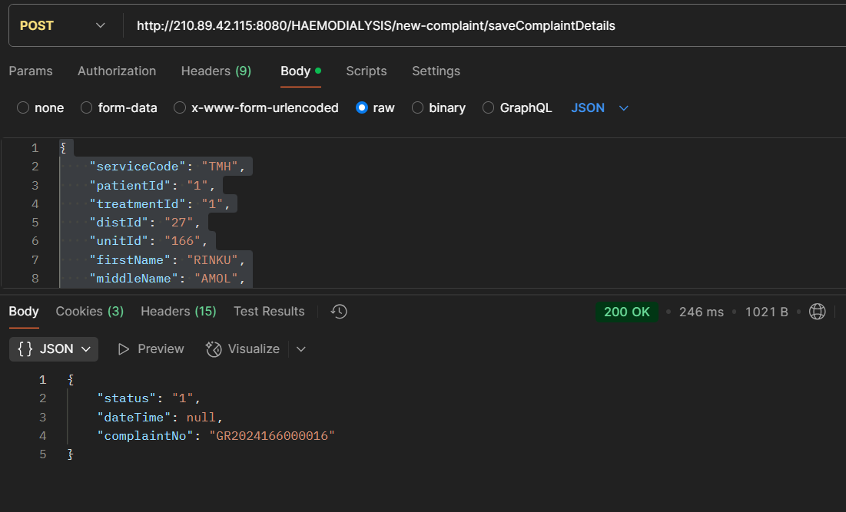

Dropdown value api

http://210.89.42.115:8080/Hemodialysis-Apis/dropdown/getAllDropDownList

